Business Process Management
Retail Credit Solutions LLM
Business Requirements and System Functional Specification

[Version:1.0]
[Version date: 31/10/2025]

Document Version Control
Version | Date | Author | Comment
1.0 | 30/10/2025 | Catherine Karanja | Initial Draft

Document Signoff
Name | Position | Signed | Dated
Geodfrey Kirui | Lead, Workflow Delivery | TO BE DONE ON DOCUMENT APPROVAL
Francis Gitau | Senior Manager, Commercial & SME Credit Analysis
Joseph Mugambi | Head, Retail Credit Solutions
Patrick Muchoki | Head, Business Process Management

Referenced Documents
Name | Version | Author
Retail Credit Policy Documents | Current | NCBA Retail Credit Division

Glossary

Acronyms
Term | Meaning
BRD | Business Requirement Document
AI | Artificial Intelligence
LLM | Large Language Model

Table of Contents
Contents
1 Glossary 5
1.1 Acronyms 5
2 Introduction 7
2.1 Business Requirements Overview 7
2.2 Key Business objectives 7
2.3 Project Scope 8
2.3.1 In scope 8
2.3.2 Out of Scope 8
3 Business Environment 9
3.1 Current Business Description 9
3.2 Business Requirements Summary 9
3.3 Business Rules 9
3.3.1 FUNCTIONAL Requirements 9
3.3.2 tECHNICAL Requirements 10
4 Assumption, Dependencies, & Risks 11
4.1 Assumptions 11
4.2 Dependencies 11
4.3 Risks 12
5 Benefits Analysis 13
5.1 Qualitative Benefits 13
5.2 Quantitative Benefits 13
6 Process Flows 15
6.1 As Is Process 15
6.2 To-Be Process 15
7 Sample Functional Requirements 17
7.1 Types of Users 17
7.2 Reports 17
8 Technical Requirements 19
8.1 General Requirements 19
8.2 User Interface Requirements 19
8.3 Performance Requirements 19
8.4 Security Requirements 19
8.5 Service Level Requirements 19
8.6 Operational Maintenance Requirements 19
9 System Overview 21
9.1 System Architecture 21
10 External Interface Requirements 22
10.1 User Interfaces 22
10.2 Hardware Interfaces 22
10.3 Software Interfaces 22
10.4 Communication interfaces 22

Introduction

Business Requirements Overview
The Retail Credit LLM Solution leverages Azure AI Large Language Model capabilities to enhance decision-making and operational efficiency within NCBA Bank’s retail credit processes. The solution enables staff to quickly retrieve, interpret, and summarize key credit policy and procedure information from internal repositories such as Policy Hub and related systems. By automating information access and contextual responses, the LLM improves turnaround time, supports consistent credit evaluations, and enhances staff productivity. This AI-driven approach reduces manual document searches, minimizes policy interpretation errors, and fosters data-driven lending decisions across the retail credit value chain.

Key Business objectives
The objectives of the retail credit solutions LLM are as follows:
• Streamline information access for Retail Credit Analysts to enhance turnaround time on credit assessments.
• Ensure consistent and accurate policy interpretation through AI-assisted responses.
• Improve decision quality and compliance by centralizing institutional knowledge.
• Reduce manual document search effort, freeing up time for higher-value analysis.
• Enable a scalable AI framework that supports future expansion into other credit domains.

Project Scope

In scope
The scope of the automation project covers;

• Development and deployment of an AI-powered LLM model hosted on Azure AI Foundry.
• Integration with Policy Hub and other internal document repositories.
• Implementation of Microsoft teams interface for Retail Credit Solutions team.
• Training and fine-tuning of the LLM using internal policy and procedural data.
• User training, testing, and rollout within the Retail Credit Solutions division.

Out of Scope
The retail credit solutions LLM project scope will NOT entail
• Integration with third-party credit scoring systems or core banking systems.
• Deployment to other departments beyond Retail Credit in Phase 1.

Business Environment

Current Business Description
Currently, Retail Credit Officers manually search through policy documents, procedural guides, and email communications to access relevant credit evaluation information. This manual process is time-consuming and prone to misinterpretation or inconsistent application of credit policy. The LLM solution provides a centralized, AI-powered interface for instant access to contextually accurate policy insights.

Business Requirements Summary
The Retail Credit LLM Solution aims to improve operational efficiency, enhance policy adherence, and support faster, data-driven credit decision-making by automating document interpretation and policy retrieval.

Business Rules

Functional Requirements
• Natural language query support for Retail Credit analysts to retrieve relevant policy information.
• Summarization of lengthy documents and extraction of key decision criteria.
• Contextual response generation referencing the latest policy updates.
• Administrative dashboard for monitoring user engagement and usage patterns.
• Role-based access control for Retail Credit staff.

Technical Requirements
• The solution will be hosted on Azure AI Foundry leveraging NCBA’s Azure environment.
• Data ingestion from Policy Hub repositories in PDF formats.
• Secure authentication via NCBA Active Directory (SSO).
• Encryption of stored and transmitted data.
• Compliance with NCBA data governance and security frameworks.

Assumption, Dependencies, & Risks

Assumptions
Expected Assumptions of the Retail Credit Solutions LLM:

- Azure AI Foundry has been provisioned within NCBA’s secure environment and is fully accessible to the Retail Credit team.
- Retail Credit policy documents and guidelines are available, accurate, and maintained within the Policy Hub repository.
- End users (Retail Credit Officers and Managers) have active NCBA Active Directory accounts and can securely access the system.
- The LLM model will operate within the approved NCBA data governance and compliance framework.
- User queries and data will remain confidential and not be shared outside NCBA systems.
- Adequate training and user orientation will be provided before go-live.

Dependencies
The successful rollout of this solution depends on the following:
- Azure AI Foundry Platform: For model deployment, management, and access control.
- Policy Hub Repository: Acts as the primary data source for policies and procedures.
- NCBA IT Infrastructure: Provides hosting, connectivity, and maintenance for the application.
- Active Directory Integration: Ensures secure authentication and user identity management.
- Retail Credit Team Availability: Participation in user testing, validation, and adoption activities.

Risks
The potential risks identified for this project include:
- Model Accuracy Risk: The AI model may generate incomplete or incorrect responses (hallucinations) if not properly tuned or validated.
Mitigation: Establish a governance process for regular model evaluation and prompt testing.
- Adoption Risk: Users may resist transitioning from manual searches to AI-assisted workflows.
Mitigation: Conduct structured training and awareness sessions.
- Data Quality Risk: Outdated or poorly structured documents in Policy Hub may impact AI output quality.
Mitigation: Ensure regular review and curation of documents used for model training.
- Security Risk: Unauthorized access to sensitive policy information.
Mitigation: Enforce RBAC, encryption, and audit logging.
- Operational Risk: Downtime or latency due to Azure service dependencies.
Mitigation: Implement service-level monitoring and fallback mechanisms

Benefits Analysis

Qualitative Benefits
• Faster access to critical policy information improves turnaround time.
• Enhanced policy interpretation consistency reduces compliance risks.
• Improved employee productivity and decision quality.
• AI-enabled knowledge retention and reuse across credit operations.

Quantitative Benefits
- Estimated 30-40% reduction in time spent per credit application review.
Expected improvement in compliance accuracy by 25% through standardized responses.

Process Flows

As Is Process
The current Retail Credit process for accessing and interpreting policy information is manual and fragmented. Retail Credit analysts and Relationship Managers must:
- Search for policies and procedures across Policy Hub.
- Manually read and interpret the policies to apply them to each credit case.
- Seek clarifications from supervisors when uncertain, causing delays in decision-making.
This manual process leads to:
- Inconsistent policy interpretation.
- Prolonged turnaround times for credit evaluation and approval.
- Increased operational risk due to reliance on individual judgment.
- Limited visibility into commonly asked policy queries and areas of confusion.

To-Be Process
With the Retail Credit LLM Solution, the process becomes automated, intelligent, and centralized.
Retail Credit Officers will:
- Access to the LLM-powered interface hosted on Azure AI Foundry through the NCBA intranet.
- Input natural language queries (e.g., “What is the policy for unsecured loan top-ups?”).
- Instantly receive summarized, policy-based responses generated by the LLM, with source document references.
- View clarifications or links to the specific Policy Hub document sections.
- Provide feedback on response quality to support model improvement.
Outcome:
- Reduced turnaround time for credit decisions.
- Consistent application of policy.
- Enhanced transparency and traceability of policy usage.
- Strengthened decision support and staff empowerment.

System Specification

System Overview

System Architecture

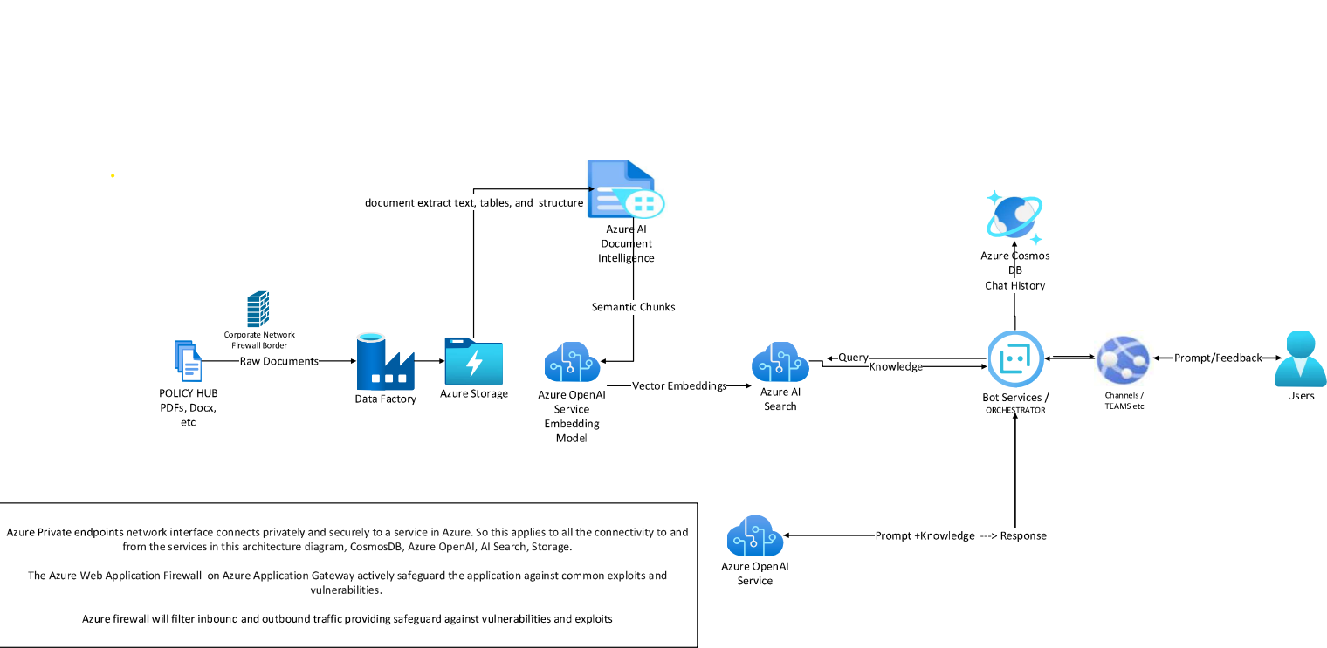
The system architecture of the application entails:
- Microsoft Teams – This serves as the user interface where retail credit solutions users interact with the LLM chatbot. Users can input prompts, ask questions, and receive responses directly within Teams.
- Azure AI Foundry – The solution is built and orchestrated on Azure AI Foundry, which hosts the Large Language Model, manages prompt processing, and delivers intelligent responses based on the bank’s knowledge sources and policies.
- Azure Cosmos DB – This acts as the data store for the application, capturing user prompts, interactions, and feedback. It supports ongoing learning, tracking, and improvement of model performance and user experience.

External Interface Requirements

User Interfaces
The Retail Credit LLM Solution will use Microsoft Teams as the primary user interface. Retail Credit users will interact with the chatbot directly within Teams to input prompts, ask questions, and receive responses.

Hardware Interfaces
The Retail Credit LLM Solution has no external hardware interfaces.

Software Interfaces
The Retail Credit LLM Solution will utilize the following software interfaces:
- Azure AI Foundry, for hosting and managing the LLM and orchestrating responses.
- Azure Cosmos DB, for storing prompts, responses, and user feedback.
- Microsoft Graph API, for secure integration with Teams and Azure services.

Communication interfaces
The Retail Credit LLM Solution will use NCBA Microsoft Active Directory for user authentication and access control.

